**Texture**

**Objective**: we're going to add some texture to our world to make it look more interesting.

1. Let’s go to [Unity's Asset Store](https://assetstore.unity.com/) and look for Rock Texture. Make sure to set the filter to free.
2. When you find an asset you want to try out click “**Add to My Assets**” and **Open in Unity**
3. If that didn’t work then in unity click on the Asset Store tab and find your assets and click download.



1. Click Import and select all then import again. You should now have new assets to play around with.

**Applying Texture**

1. Click on your terrain, click on your Paint Brush tool and in the dropdown menu select **Paint Texture**.
2. Under Terrain Layers select **Edit Terrain Layers** -> **Create Layer**.



Select the texture you want to use. Keep in mind this will cover all of your terrain and will be your “default” texture for the time being.

1. Select your **NewLayer** material in your Assets window and in the inspector you should see a **Normal Map attribute**.

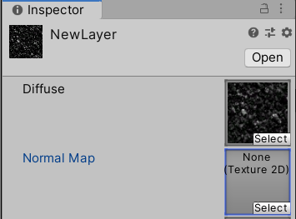

1. Click **select** and find your previously chosen layer. Notice that your texture should come with a “partner” texture that’s slightly blue with a similar name except with the suffix **Norm**. Go ahead and select this.

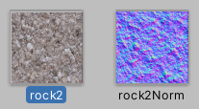

**Lesson**

**Bump Map** is used to refer to pretty much the category of these textures. That have information on how the light catches a shape and says to that shape, you need to look like you are raised and lowered.

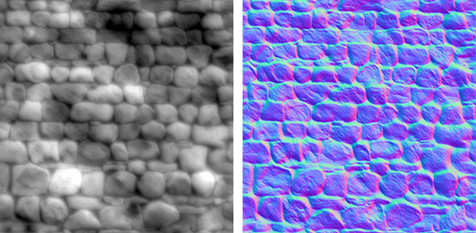

**Height Map** – Uses with-to-black scale to show height

**Normal Map** – Uses RGB values to indicate x,y,z facing direction. In short It's using RGB, so color information to say what direction a pixel or a point is facing.

1. Click on the terrain and scroll down in the inspector. Find your **Terrain Layers** and change the **Normal scale** to **100** so we can see the Texture in more detail. If you don’t like it play around with the numbers.

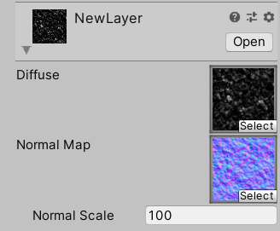

1. Click on Edit Terrain Layers again. Select Create Layer and select another texture. Don’t forget to add its NORM Map too! Now if you select the 2nd layer and left click on the terrain you should be able to paint your terrain.

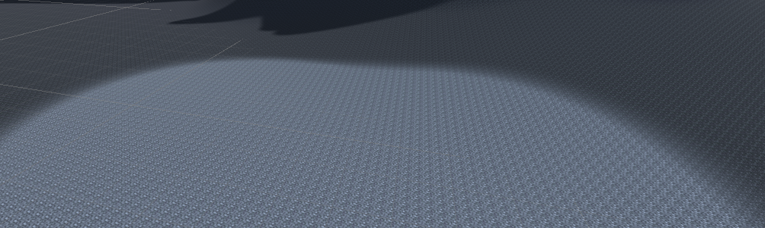

Note that both textures have metallic and smoothness sliders that will change the texture visuals. Also if your texture is not detailed go to **Tiling Settings** and increase the X and Y size to your liking.

**Challenge**: Set up terrain textures and create your world.